### 701: Evidence Reference Matrix – Portfolio of Evidence

|  | **Pass criteria (for reference only)** | **Distinction criteria**  **(for reference only)** | **Evidence type(s)** | **Evidence reference** | **IEPA comments (in preparation for Professional Discussion)**  **IEPA only** |
| --- | --- | --- | --- | --- | --- |
| **Apprentice name:** | | | | | |
| **Knowledge, Skills and Behaviours**  K1: all stages of the software development lifecycle (what each stage contains, including the inputs and outputs). | | | | | |
|  | Describes all stages of the software development lifecycle. | N/A | PDF Document | /Docs/Software Development Lifecycle At Labman.pdf |  |
| **Knowledge, Skills and Behaviours**  K3: the roles and responsibilities of the project lifecycle within your organisation, and your role. | | | | | |
|  | Describes the roles and responsibilities of the project lifecycle within their organisation, and their role. | N/A | PDF Document | /Docs/Roles and Responsibilities During the Project Lifecycle At Labman.pdf |  |
| **Knowledge, Skills and Behaviours**  K4: how best to communicate using the different communication methods and how to adapt appropriately to different audiences.  S15: communicate software solutions and ideas to technical and non-technical stakeholders. | | | | | |
|  | Describes methods of communicating with all stakeholders that is determined by the audience and/or their level of technical knowledge. | Compares and contrasts the different types of communication used for technical and non-technical audiences and the benefits of these types of communication methods. | PDF Document | /Docs/Communication Methods Between Stakeholders At Labman.pdf |  |
| **Knowledge, Skills and Behaviours**  K5: the similarities and differences between different software development methodologies, such as agile and waterfall. | | | | | |
|  | Describes the similarities and differences between different software development methodologies, such as agile and waterfall. | N/A | PDF Doc | /Docs/Proposal for Software Project Management Methodology.pdf |  |
| **Knowledge, Skills and Behaviours**  K7: software design approaches and patterns, to identify reusable off-the-shelf solutions to commonly occurring problems. | | | | | |
|  | Suggests and applies different software design approaches and patterns, to identify reusable solutions to commonly occurring problems (include bespoke or off-the-shelf) | Evaluates and recommends approaches to using reusable solutions to common problems. | PDF Docs  Word Doc | /Design Patterns  /Docs/Optimizing Feedback Method Overview.docx |  |
| **Knowledge, Skills and Behaviours**  K8: organisational policies and procedures relating to the tasks being undertaken and when to follow them, eg the storage and treatment of GDPR sensitive data.  S14: follow company, team or client approaches to continuous integration, version and source control. | | | | | |
|  | Explains the relevance of organisational policies and procedures relating to the tasks being undertaken, and when to follow them including how they have followed company, team or client approaches to continuous integration, version, and source control. | N/A | PDF Docs | /Docs/Organizational and Procedures At Labman For Source Control.pdf |  |
| **Knowledge, Skills and Behaviours**  K10: principles and uses of relational and non-relational databases. | | | | | |
|  | Applies the principles and uses of relational and non-relational databases to software development tasks. | N/A | PDF Doc  Word Doc | /Docs/Relational and Non-relational Databases at Labman.pdf  /Docs/Optimizing Feedback Method Overview.docx |  |
| **Knowledge, Skills and Behaviours**  K12: software testing frameworks and methodologies. | | | | | |
|  | Describes basic software testing frameworks and methodologies. | Evaluates the use of various software testing frameworks and methodologies and justifies their choice. | PDF Doc | /Software Testing Frameworks |  |
| **Knowledge, Skills and Behaviours**  S2: develop effective user interfaces. | | | | | |
|  | Explains their own approach to development of user interfaces. | N/A | PDF Docs | /Designing UI At Labman |  |
| **Knowledge, Skills and Behaviours**  S3:link code to data sets. | | | | | |
|  | Explains how they have linked code to data sets. | N/A | PDF Doc  Word Doc | /Docs/Relational and Non-relational Databases at Labman.pdf  /Docs/Optimizing Feedback Method Overview.docx |  |
| **Knowledge, Skills and Behaviours**  S5: conduct a range of test types, such as Integration, System, User Acceptance, Non-Functional, Performance and Security testing.  S13: follow testing frameworks and methodologies. | | | | | |
|  | Illustrates how to conduct test types, including Integration, System, User Acceptance, Non-Functional, Performance and Security testing including how they have followed testing frameworks and methodologies. | N/A | PDF Docs | /Testing The Holiday System |  |
| **Knowledge, Skills and Behaviours**  S8: create simple software designs to effectively communicate understanding of the program. | | | | | |
|  | Creates simple software designs to communicate understanding of the programme to stakeholders and users of the programme. | N/A | PDF Doc | /Docs/Software Designs At Labman.pdf |  |
| **Knowledge, Skills and Behaviours**  S9: create analysis artefacts, such as use cases and/or user stories. | | | | | |
|  | Creates analysisartefacts, such as use cases and/or user stories to enable effective delivery of software activities. | N/A | PDF Doc | /Docs/Analysis Artefacts at Labman.pdf |  |
| **Knowledge, Skills and Behaviours**  S17: interpret and implement a given design whist remaining compliant with security and maintainability requirements. | | | | | |
|  | Explains, how they have interpreted and implemented a given design whilst remaining compliant with security and maintainability requirements. | N/A | PDF Doc | /Docs/Security and Maintainability Compliance At Labman.pdf |  |
| **Knowledge, Skills and Behaviours**  B1: works independently and takes responsibility, eg has a disciplined and responsible approach to risk, and stays motivated and committed when facing challenges. | | | | | |
|  | Describes how they have operated independently to complete tasks to given deadlines which reflect the level of responsibility assigned to them by the organisation. | N/A | PDF Docs  Witness Statement | /Working Independently at Labman  /Docs/Witness Statements.pdf |  |
| **Knowledge, Skills and Behaviours**  B4: works collaboratively with a wide range of people in different roles, internally and externally to the team, with a positive attitude to inclusion & diversity. | | | | | |
|  | Illustrates how they have worked collaboratively with people in different roles, internally and externally, which show a positive attitude to inclusion & diversity. |  | PDF Doc  Witness Statement | /Docs/Collaborative Working At Labman.pdf  /Docs/Witness Statements.pdf |  |
| **Knowledge, Skills and Behaviours**  B5: acts with integrity with respect to ethical, legal and regulatory ensuring the protection of personal data, safety and security. | | | | | |
|  | Explains how they have established an approach in the workplace which reflects integrity with respect to ethical, legal, and regulatory matters and ensures the protection of personal data, safety and security. | N/A | PDF Doc | /Docs/Protection of Personal Data, Safety and Security At Labman.pdf |  |
| **Knowledge, Skills and Behaviours**  B6: shows initiative and takes responsibility for solving problems within their own remit, being resourceful when faced with a problem to solve. | | | | | |
|  | Illustrates their approach to meeting unexpected minor changes at work and outlines their approach to delivering within their remit using their initiative. | N/A | PDF Doc  Word Doc  Witness Statement | /Docs/Unexpected Change Management at Labman.pdf  /Docs/Optimizing Feedback Method Overview.docx  /Docs/Witness Statements.pdf |  |
| **Knowledge, Skills and Behaviours**  B7: communicates effectively in a variety of situations to both a technical and non-technical audience. | | | | | |
|  | Explains how they have communicated effectively in a variety of situations to both a technical and non-technical audience. | N/A | PDF Doc | /Docs/Communication Methods Between Stakeholders At Labman.pdf |  |
| **Knowledge, Skills and Behaviours**  B8: shows curiosity to the business context in which the solution will be used, displaying an inquisitive approach to solving the problem. This includes the curiosity to explore new opportunities, and techniques; the tenacity to improve methods and maximise performance of the solution; and creativity in their approach to solutions. | | | | | |
|  | Illustrates how they have responded to the business context with curiosity to explore new opportunities and techniques and tenacity to improve solution performance. | N/A | PDF Doc  Witness Statement | /Docs/My Curiosity In Business Context At Labman.pdf  /Docs/Witness Statements.pdf |  |
| **Knowledge, Skills and Behaviours**  B9: demonstrates creativity and tenacity in their approach to solutions and the methods used to come to a solution for example, sees the task through to the end by devising new solutions and despite obstacles and problems along the way. | | | | | |
|  | Illustrates how they have established an approach to methods and solutions which reflects a determination to succeed. | N/A | PDF Docs  Witness Statement | /My Determination To Succeed  /Docs/Witness Statements.pdf |  |
|  |  |  |  |  |  |
| **Knowledge, Skills and Behaviours**  B10: committed to continued professional development. | | | | | |
|  | Explains how they reflect on their continued professional development and act independently to seek out new opportunities. | N/A | PDF Doc  Word Doc  Witness Statement | /Docs/My Commitment To Continued Professional Development.pdf  /Docs/Read 'Building Microservices by Sam Newman' notes.docx  /Docs/Witness Statements.pdf |  |

### 

### 701: Declaration of Authenticity – Portfolio of Evidence

The Declaration of Authenticity must be completed as appropriate and submitted to City & Guilds with the apprentice’s evidence for End-point assessment.

| Apprentice  Name | Arthur Clarkson | Enrolment  Number | 1234567 |
| --- | --- | --- | --- |

**Apprentice declaration:**

**I confirm that all work submitted is my own and that I have acknowledged any sources I have used.**

|  |  |  |  |
| --- | --- | --- | --- |
| **Apprentice** | Signature | **Date** | DD/MM/YY |

**Line manager declaration:**

**I confirm that all work was conducted under conditions designed to assure the authenticity of the apprentice’s work, and am satisfied that, to the best of my knowledge, the work produced is solely that of the apprentice.**

|  |  |  |  |
| --- | --- | --- | --- |
| **Line Manager** | Signature | **Date** | DD/MM/YY |

**Training provider declaration:**

**I confirm that the evidence presented by the apprentice is ready for End-point assessment. It is valid, authentic, reliable and current and sufficient to meet the requirements of the relevant standard.**

|  |  |  |  |
| --- | --- | --- | --- |
| **Training Provider** | Name & Signature | **Assessment Date** | DD/MM/YY |

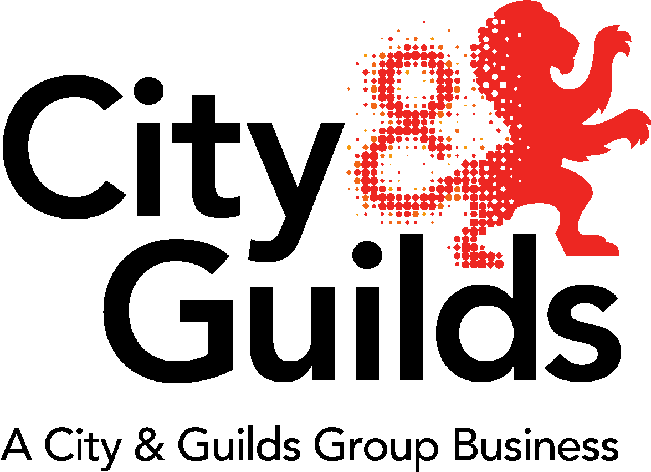

### 701: Apprentice Portfolio Checklist – Portfolio of Evidence

| Portfolio checklist | | Tick when confirmed |
| --- | --- | --- |
| 1. | Is all evidence signed by the apprentice and dated? *  E-signatures are also acceptable |  |
| 2. | Is all evidence valid, authentic, current and sufficient (VACS)? |  |
| 3. | Does evidence clearly show it is the apprentice’s individual work (and if involved in team work is it clear the specific contribution the apprentice made)? |  |
| 4. | Does the evidence clearly demonstrate their relevant knowledge? |  |
| 5. | Have you used the evidence reference form? And has all evidence been referenced? |  |
| 6. | Does it showcase the apprentice’s best pieces of work? |  |
| 7. | Is the majority of the evidence holistic in its nature? |  |
| 8. | Have you checked that you have not included any pieces of evidence that are duplicated or not relevant? |  |
| 9. | Is there sufficient evidence to cover the whole of the criteria and grading descriptors that has been referenced to? |  |
| 10. | Are any witness testimonies or employer references tailored to the apprentice? |  |
| 11. | Has any client/customer reference information been anonymised? |  |
| 12. | Have all external sources of information being appropriately documented and referenced to the original source, showing clear understanding of how they relate to the criteria? |  |
| 13. | Has the appropriate stakeholder(s) eg employer/training provider checked whether the apprentice’s portfolio meets all the required criteria and grading descriptors? |  |
| * where witness testimonies are included as a piece of evidence these do not need to be signed by the apprentice but instead must be signed/authenticated as outlined in the rest of the EPA pack | | |
| **Reminder:**  You must upload the completed ‘Evidence Reference Matrix’ to EPA Pro in word format | | |